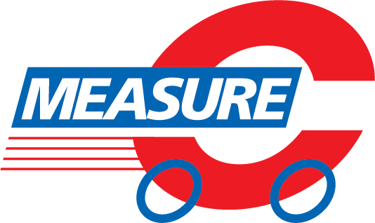

Expression of Interest to serve on the
Measure C Renewal Committee

The Measure C Renewal Committee is responsible for developing both a draft and final expenditure plan for the proposed 2026 Measure C sales tax extension, which will be placed on the 2026 ballot. Committee members will engage in a collaborative, participatory process, contributing their expertise and perspectives as representatives of Fresno County taxpayers. Their work will help ensure that the renewal plan reflects the community's needs and priorities for improvements throughout the region. Committee members may expect to meet monthly for up to two hours at minimum, with the first meeting anticipated to be a half-day. Additional topic specific subcommittees will also meet. Only Fresno County residents are eligible to sit on the committee.

Submit application by January 31, 2025:
Email: comment@fresnocog.org
Hard Copy: Fresno COG, 2035 Tulare Street, Suite 201, Fresno, CA 93721

Applicant Information
Name __________________________________________________Date________________
Agency or group representing (if applicable) ________________________________________
Sector representing (if applicable) ________________________________________________
Title ________________________________________________________________________
Contact Email ________________________________________________________________
Preferred Contact Phone ________________________________________________________
Mailing Address _______________________________________________________________
Applicant’s Proxy Information (to attend in applicant’s absence)
Name ______________________________________________________________________
Title ________________________________________________________________________
Contact Email ________________________________________________________________
Preferred Contact Phone ________________________________________________________
Mailing Address _______________________________________________________________

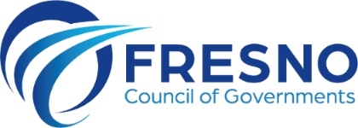

Measure C Renewal Committee Positions
Fresno COG is accepting applications from representatives in the following areas. Please check all positions you qualify to represent, and for which you wish to be considered. If you are applying on behalf of a community group, please include a letter of support from that group.

□ Active Transportation
□ ADA/Seniors
□ Agriculture
□ Aviation
□ Building/Development
□ Business
□ Community Based
Organization
□ Education
□ Emergency Services/
Public Safety
□ Environment/
Conservation
□ Goods Movement
□ Health
□ Labor
□ Political Advocates
□ Transit
□ Tribal Governments
□ Public-at-Large

Please submit answers to the following questions:
1. Why do you wish to participate in the Measure C Renewal Committee?

2. Who are your constituents and where are they located? (city, town or zip codes)

3. What is the stated mission of that organization or sector?

4. Have you been officially designated by that organization or sector to represent them on the Renewal Committee? (Please attach letter of recommendation.)
□ Yes □ No
5. What are some of your sponsoring group's transportation needs or concerns regarding the Measure C Renewal Plan?

Applicant Signature/Date

